Session-7 Database
- Create a table called Restaurant with columns: id, name, location, and cuisine. Apply NOT NULL constraint to name and location, and make id the PRIMARY KEY.
Ans.
CREATE TABLE Restaurant (
id INT PRIMARY KEY,
name VARCHAR(100) NOT NULL,
location VARCHAR(100) NOT NULL,
cuisine VARCHAR(100)
);
Output
Query OK, 0 rows affected

- Create a table called FoodOrder with columns: order_id, restaurant_id, user_id, and order_total. Set order_id as PRIMARY KEY, and add a FOREIGN KEY constraint on restaurant_id referencing Restaurant(id).
Ans.
CREATE TABLE FoodOrder (
order_id INT PRIMARY KEY,
restaurant_id INT,
user_id INT,
order_total DECIMAL(10,2),
FOREIGN KEY (restaurant_id) REFERENCES Restaurant(id)
);
Output
Query OK, 0 rows affected

- Insert 6 rows into a table called SpotifyUser with columns: user_id, username, email, and subscription_type. Ensure that username is UNIQUE and email is NOT NULL.<br><br><em><strong>Hint:</strong> Use the UNIQUE and NOT NULL constraints when creating the table.</em>
Ans.
Step 1: Create the SpotifyUser table
CREATE TABLE SpotifyUser (
user_id INT PRIMARY KEY,
username VARCHAR(50) UNIQUE,
email VARCHAR(100) NOT NULL,
subscription_type VARCHAR(20)
);
Step 2: Insert 6 rows
INSERT INTO SpotifyUser (user_id, username, email, subscription_type)
VALUES
(1, 'maitri01', 'maitri01@gmail.com', 'Free'),
(2, 'rahul22', 'rahul22@gmail.com', 'Premium'),
(3, 'priya07', 'priya07@gmail.com', 'Premium'),
(4, 'amit99', 'amit99@gmail.com', 'Free'),
(5, 'neha18', 'neha18@gmail.com', 'Premium'),
(6, 'karan55', 'karan55@gmail.com', 'Free');
Output
Query OK, 6 rows affected
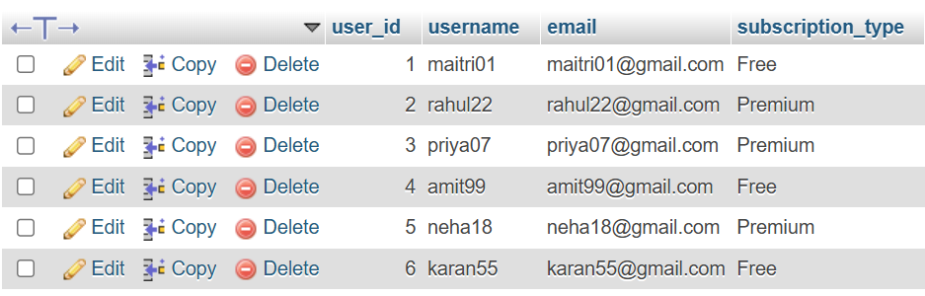

- Create a VIEW named TopSpendersView that shows usernames and order_total from a FoodOrder table where order_total is greater than 1000.
Ans.
CREATE VIEW TopSpendersView AS
SELECT s.username, f.order_total
FROM FoodOrder f
JOIN SpotifyUser s
ON f.user_id = s.user_id
WHERE f.order_total > 1000;
SELECT * FROM TopSpendersView;
Output
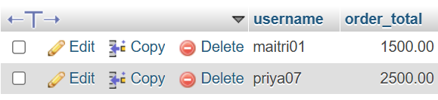
2 rows in set (0.00 sec)
- Write a SQL query to list all users from the TopSpendersView who have spent more than 2000, sorted by order_total descending.<br><br><em><strong>Constraint:</strong> Only use the TopSpendersView for your query, not the original FoodOrder table.</em>
Ans.
SELECT username, order_total
FROM TopSpendersView
WHERE order_total > 2000
ORDER BY order_total DESC;
Output
